To install Terraform on Windows

<https://developer.hashicorp.com/terraform/install> 🡪 Windows 🡪 AMD64 🡪 Download

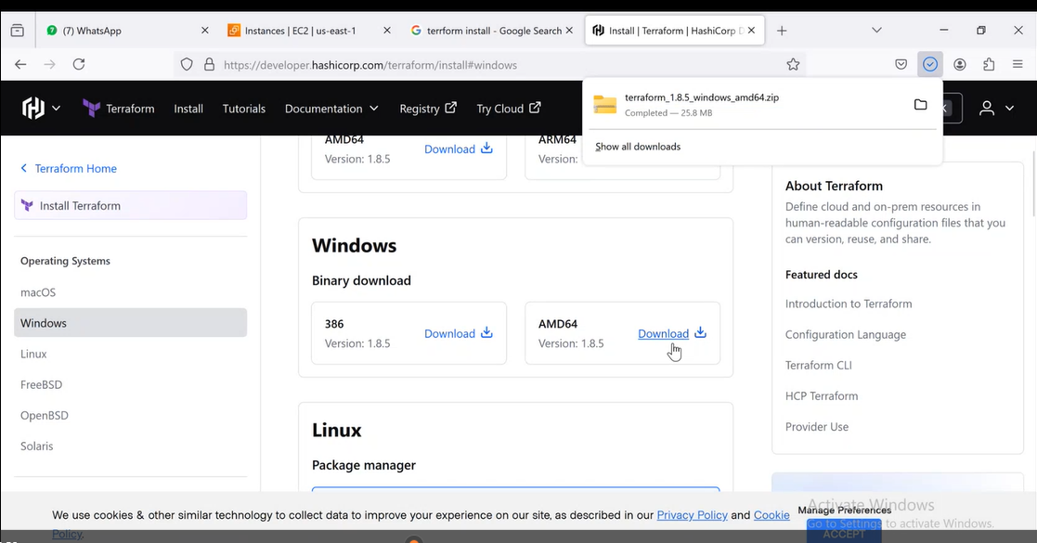

Create a ‘Terraform’ named directory at following location

C:\Program files\Terraform

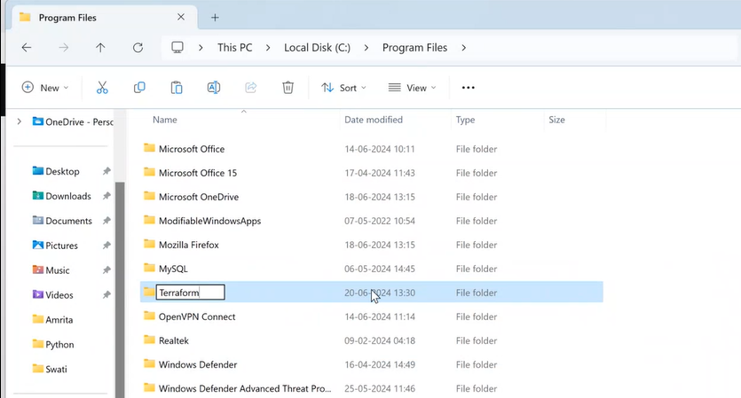

Copy terraform.exe file from downloaded zip and paste at this folder.

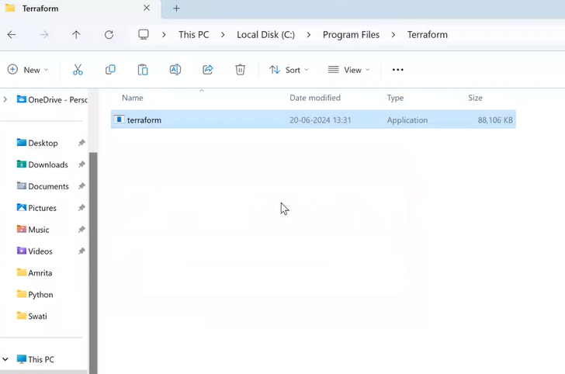

In windows search 🡪 search for environment variables 🡪 click on edit the system environment variables

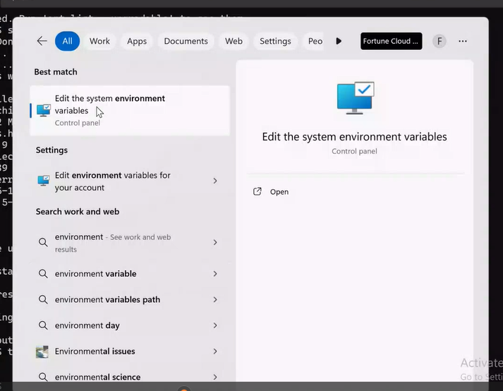

Click on Environment Variables

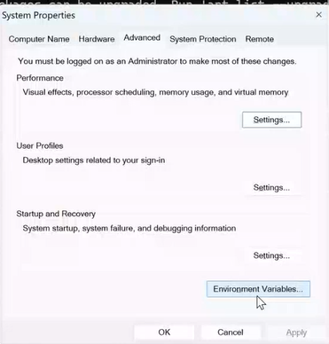

System variables 🡪 path 🡪 edit

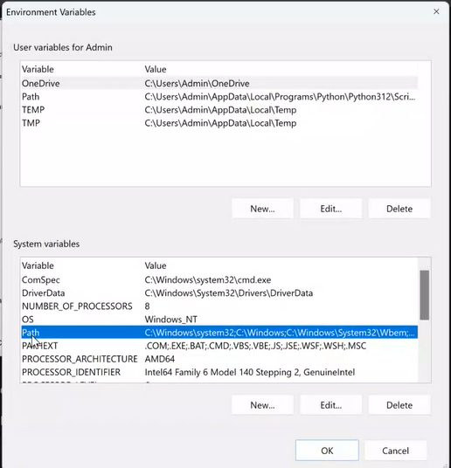

Then click on New

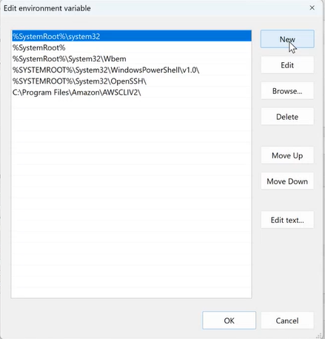

Copy the path of Terraform folder and paste here

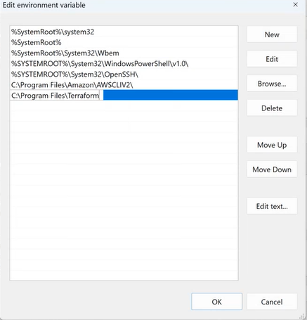

Click on OK

Open Windows Powershell and check the version of terraform

terraform --version

